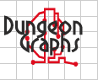
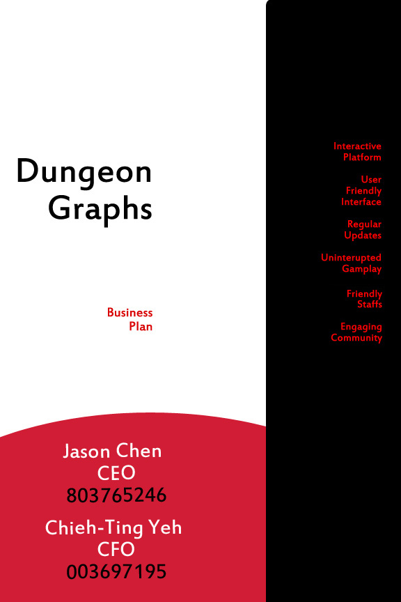

Table of Contents

I. Executive Summary 3
II. Opportunity and Market Analysis 4
III. Solution: Product or Service 4
IV. Marketing and Sales 5
V. Competitor Analysis 6
VI. Risks and Mitigation 7
VII. Organization 8
VIII. Financial Plan 8
IX. Financial Harvest 9
X. Appendix 11
XI. Bibliographhy------------------------------------------------------------------------------------15

- Executive Summary
The General Overview

Business Concept: Many people who play tabletop games such as Dungeon and Dragons have problems getting a group together to play. Distance from one another, scheduling conflicts, and many other factors can prevent a group of friends from meeting. As a result there is a large opportunity pull on the tabletop gaming market. However, Dungeon Graphs offers a solution by letting players meet through the internet. Friends can meet up for short sessions instead of a whole day and they don't have to deal with the issue of driving from place to place. Rather than spend large amounts of money on miniatures for the game, customers can use virtual figures for their character. Dungeon Graphs will offer a way for users to keep track and modify their character stats through templates designed for certain games.
Market, Customer, Industry: The tabletop industry is definitely where Dungeon Graphs will focus on the most. To begin, we will target the audiences that play the various versions of Dungeons and Dragons as they are the largest portion of the tabletop players. Of these people, we then target the young adults who are graduating from high school and moving to college. Although the tabletop audience has over one million players, we will initially target the market located in California .These young adults would be interested in Dungeon Graphs as it eliminates the need to set up a meeting spot. Aside from these people, we would target the people who wish to play the game but lack an established group. On the Wizards of the Coasts forums, many potential players express their desire to play the game but lament the fact that they cannot due lack of friends interested in the game. Dungeon Graphs would be able to introduce these players to new groups and teach them how to play through the use of a streamlined user interface.
Marketing and Sales Strategy: We will place advertisements for Dungeon Graphs on popular websites and magazines that have tabletop content such as Order of the Stick. To further advertise our product, we will create videos demonstrating how simple the software is. Currently, our competitors are the groups that own the tabletop games such as Wizard of the Coast and similar software such as Fantasy Grounds. However, Dungeon Graphs plans to establish a business model that is based on quick updates to the software, bug fixes, and optional downloadable content which these other companies do not have. For the market research, we will invite people from the market to form focus groups. Over time, we will ask for customers to fill out surveys and off incentive in the form of paid subscription and other products.
Organization and Key Leaders: Currently, Dungeon Graphs only has Chieh-Ting Yeh and Jason Chen as primary developers and financial planner for the platform. Jason Chen is a third year Computer Science major at UCLA who is no stranger to the difficulties of organizing a game of Dungeons and Dragons. In order to be successful, we are looking for at least two more strong programmers to help us design and code the software. Initially, Jason will focus on developing the application while Chieh-Ting Yeh determines the advertisements and finance. As the company expands, Jason will move away from coding toward managing the organization. The company will eventually hire additional people for financial management and coding.
Financial Plan: As time passes, we expect the number of customers to increase steadily as news of the service spreads. We plan to charge $1.99 for each session played per customer as well as have various other payment plans. We expect roughly 30,000 users after the initial year as well roughly 400,000 dollars in net revenue. We hope to increase the number of users by 25% each month.
Financing and key allies required: We will need very little money to start off as the majority of this project will be done with code. However, we will probably need around 60,000 dollars for initial development costs and servers. Much of the funds can be from private borrowing. If we can get a partnership with already established companies such as Wizards of the Coast or Games Workshop, the number of customers will probably grow exponentially. Furthermore, gaining the support of the companies will lessen the possibility of copyright violation. Although the product does not violate copyright laws at all as it merely provides a location to play, there is a possibility of time being wasted by being taken to court.

- Opportunity and Market Analysis
The research

For this market projection, the product that we will be using is a program called Dungeon Graphs that allows people to play tabletop games over the internet. Ever since 1997, the people who have been exposed to Dungeons and Dragons have been estimated to be roughly over one billion. People who commonly play tabletop games are young adults or adults who often have large amounts of disposable income. Furthermore, they are primarily the people who have a lot of time to go too far places for a long period of time. For these reasons, we will target mainly college students who are either enrolled in public, private, or graduate colleges located in California who don’t have large incomes or the ability to travel long distances. We believe that a subscription based cost will appeal and be affordable to people of this demographic as the cost will be preferable to the large amount spent on the tabletop alternative. Although our target demographic is mainly people from the ages of 18-24, both older and younger people might still be drawn to the product. Due to the subscription nature of this product, income will most likely be continuous. Initial advertisements will be placed in magazines and websites that people from the ages of 18-24 visits but as the number of subscribers increase, the advertisements will be placed in much more areas.

In figure 1in the appendix; we can see an upward trend in the amount of people attending public, private, or graduate colleges in California. The only slight variation in this projection is in 2009 when the amount of people enrolled is less than the amount of people enrolled in 2008. However in 2010, the amount of people enrolled resumes its upward trend. As a result, it is highly likely that demand for our product will grow as more people attend college. The graph begins at 2005 because that was when the first census targeting the 18-24 age group attending college took place. Because of this, there is only data over a six year period. However despite that, it is still possible to see the predicted outcome in 2022. If this trend persists, by 2022, there should be about 26,000,000 people currently enrolled in college. This is very favorable for our product as out of that large number of people, there will undoubtedly be portions that are tabletop players. Aside from the number of people in California, there are also millions of people over the world that play Dungeons and Dragons. If we place advertisements in websites and magazines that have tabletop content such as Order of the Stick or White Dwarf magazines, it will be possible to spread news all over California. Furthermore, colleges are great places for news to spread. If we could possibly get campus representatives at all the California colleges, we can get even more people to use our product.

- Solution: Product or Service
Gaming platform for everyone anytime, anywhere

Dungeon Graphs is software that will allow people to play tabletop games over the internet. This interactive software will reduce the inconvenience caused when trying to gather a group of people to play a game. In addition to gathering large groups of people together, the software will also allow game masters to create and design their own worlds. The main tabletop game that Dungeon Graphs will focus on is Dungeons and Dragons as it has the largest audience. Dungeon Graphs will aid in making the tabletop experience as pain free as possible. Our value proposition is a simple and interactive interface for players to enjoy tabletop games on. The main benefits of Dungeon Graphs are:
Constant Speedy Updates
Currently one of the main problems plaguing existing software is the fact updates are sporadic and bugs aren’t fixed quickly enough. However, Dungeon Graphs will be maintained and updated by a group of programmers who will attempt to fix the problems as soon as possible. Updates will be consistent and frequent as rules for the games change and new content will be added as often as possible. Our programmers will take the effort to ensure that revisions to Dungeon Graphs come out as soon as the edition revisions take place.
Game Master Tools
Dungeon Graphs will allow for the game master to edit the existing world with a variety of tools. With these tools, the master can expand the world, add enemies, change settings, and many other things. Furthermore, the game master can keep track of the people playing and their various statistics. The environments and characters created by the users are tied to their account and can be sent to other people as well.
Affordable Service
Dungeon Graphs will offer affordable rates for multiple useful tools. In addition to the usual rates, there will also be deals for long time users as well as package plans. There will also be aesthetic downloadable content that the players or the game master can use to decorate their characters or environment. The content will be completely optional aesthetics as to not alienate certain users who merely wish to play the game.
Matchmaking Services
In addition to all the other benefits, Dungeon Graphs will also serve as a way to find groups of people to play with. For many people, the main issue with tabletop gaming is finding a group of people to play with. By filling out a survey indicating certain preferences, Dungeon Graphs will attempt to match you up with like-minded people. However, we will also monitor the behavior of our users. A report system will be used to maintain privacy. Our staff will be on watch for users who behave inappropriately toward others. Users who are rude or hostile toward others will be given warnings.
- Marketing and Sales
Customers, strategy, pricing

Our sales and marketing plans will mainly rely on the interaction with our customers. Initially, ads for Dungeon Graphs will be placed in magazines or websites that are frequented by tabletop gamers. Various magazines or websites include White Dwarf Magazines and Order of the Stick among many others. In these ads, we will advertise all the benefits of using Dungeon Graphs as well as our subscription based plan. Since there are over a million people who have been exposed to Dungeons and Dragons we hope to capitalize on the worldwide market eventually. Initially we will focus on the large Californian tabletop audience. But ultimately, the customers we hope to draw in will eventually extend to college students all over the world.

In order to keep the servers running at the lowest price, Dungeon Graphs will have a subscription based fee. For those we don’t play too often, there is a daily plan in which the user only pays for a single day at a time. The company plans to sell each gaming session, which lasts for 24 hours, at $1.99 per session. In those 24 hours, the user will have access to all the game master tools whether or not they are the game master as well as all the player tools. However, for those who intend to play for long periods of time, there will also be monthly and yearly plans that have slightly discounted rates. Currently the company offers package plans for 30, 180, and 365 days plans at $30, $60, and $120 respectively. In the future, there may be cheaper prices due to special promotions or events. As long as all the players have some form of subscription, they will be able to play and interact on the Dungeon Graphs servers. To ensure an enjoyable experience for users, there will also be a report system where other players can report abusive users.
To ensure that customers are properly satisfied, we will periodically ask for customers to fill out surveys detailing what they enjoyed and disliked about Dungeon Graphs. As an incentive to this form of feedback, we plan to enter everyone who submits a survey into a random drawing for various prizes. The prizes will range from downloadable content to paid subscriptions and may later include bigger products as the company grows. Eventually if companies like Wizards of the Coast enter into a partnership with us, we can offer larger and much better prizes for our customers. Customers will ultimately aid in deciding which new features they would like implemented as well as what other games they would like to see on Dungeon Graphs.
Furthermore, we eventually plan to hold meetings with the creators of tabletop games such as Wizards of the Coast or Games Workshop. In these meetings, we hope to form a partnership in which the large companies advertise our product while we promote their games. The larger companies get a larger audience as there is now a platform to play their products and we gain more customers and advertisements. The alliance formed would undoubtedly have positive benefits to both sides and enlarge the fan base of the game.
- Competitor Analysis
Know your enemies

Dungeon Graph’s competitors include the companies that made the games which we are trying to design an online platform form. Of these companies, the creators of Dungeon and Dragons, Wizards of the Coast is definitely the most prominent. Other forms of competition include the free software that others have developed like Fantasy Ground which offers an alternative to the Dungeon Graphs platform. Lastly, competition can also come from other sources of entertainment such as videogames. Large companies such as Nintendo have the potential to draw away customers through their flashy and simpler games.

Wizards of the Coast

Wizards of the Coast is the company responsible for the current state of Dungeons and Dragons. Dungeon Graphs will ultimately depend on companies like Wizards of the Coast to continually produce tabletop games that can be played using Dungeon Graphs. The company releases new versions for the tabletop game every once in a while and has recently released an online magazine called D&D Insider. Along with the magazine, there are tools that players can use to create characters and environments. However the advantage that Dungeon Graphs has over Wizards of the Coast is the ability to play the game over the internet. Although Wizards of the Coast offers many tools similar to Dungeon Graphs, the cost of using the tools is much high compared to the subscription fees of Dungeon Graphs. Furthermore, the product created using their tools needs to be printed out in order to be used. Users of D&D Insider have also complained about how sporadic updates are. Bugs and problems are often not addressed until much later.

Fantasy Ground

Fantasy Ground is another product that is very similar to Dungeon Graphs. Currently Fantasy Ground supports creation of environments and characters based on versions 3.5 and 4.0 of Dungeons and Dragons. Similar to Dungeon Graphs, they currently offer tools for the Game Master to use as well as tools for the players. In order to use Fantasy Ground, licenses are sold and players are responsible for connecting to one another. The players connect to the computer of the host in order to play the games over the internet. Although Fantasy Ground is very useful it suffers from a lack of dedicated servers. Users who have restricted internet might not be able to host games for others to join in. This is especially terrible if the host is the Game Master. However, Dungeon Graphs offers fully dedicated servers that users can interact on without the need to host using someone’s computer. The updates for Fantasy Ground are also very erratic. Updates for the existing system happen in monthly periods. At times, updates can take place after four or five months have passed.

Nintendo

Video games are one of the biggest competitors of the gaming market. Due to the arrival of video game, many people have stated that tabletop games are on the decline. Large companies such as Nintendo make games of all different genres for people of all different ages. Furthermore, handheld systems such as the Nintendo DS are seen as much more convenient compared to lugging around dice and figures. However, video games often do not allow the players to create their own worlds to interact in. Players can interact with each other in video games but often only in a set environment. Although the effects of video games are much more vibrant the players cannot create their own personal fleshed out characters. However, Dungeon Graphs allows both the players and the Game Master to have a say in the design of their world. Rather than having interactions with an electronic figure, players can interact with other people. Although Nintendo is a strong contender in the video game market, Dungeon Graphs is able to hold its own through the use of its design tools and player interaction.

- Risks and Mitigation
Uncertainties and Risks

By performing a SWOT analysis of our organization and product against the industry, we identified various risks and mitigation methods. Our company’s strengths come in the form of technical excellence and experienced staff. We possess a team of qualified developer who are experienced with the gaming community and a team of marketing experts who can easily identify feasible target markets. Our weaknesses are in the form of financial instability and lack of reputation. Initial investments and funding will be mainly from the founders. Due to the fact that our organization is privately funded by our founders, it is difficult to expand operations at an exponential scale. Furthermore, as a new company in the industry, we need to establish our reputation by paying extra attention to our product quality and customer satisfactions. The opportunity of being the first mover to come to market with this type of gaming platform is enticing enough for the company to take the risks that comes with the opportunity. Our primary threats are in the legal sectors where we need to secure our product and to battle intellectual property issues. Nevertheless, we have faith in our legal team who will be responsible for defending our application against all legal issues.

As with any successful gaming platform, Dungeon Graphs runs the risk of being widely imitated and distributed across various online channels in alternate forms. Since the primary profit for Dungeon Graphs is derived from our platforms in the form of paid game sessions, we need to maintain as many players on our platform as possible to have maximum gain. To mitigate the risks of being imitated by our competitions, Dungeon Graphs will extensively patent all aspects of our application to maintain exclusive rights over the software, platform, and the idea. The company eventually plans to hire a large team of successful patent lawyers to monitor and patent our application to ensure the continued success of our platform.

Another potential risk comes in the form of loss time and investment. Due to the fact that we have not put our platform in production, we are uncertain as to how the public will respond to our application. In order to strategically position ourselves in the best possible state upon launch, Dungeon Graphs will conduct surveys on known gaming communities such as Wizard of the Coasts and Game Workshops to figure out exactly what the users want. By conducting extensive research, we limit the possibility of an unsuccessful launch by delivering a versatile product that meets customers’ requirements and satisfaction.

Lastly, even though Dungeon Graphs do not plan to create a new game, but rather create an interactive online platform for players to play existing games, we still may potentially face litigation issues with current game makers. Though our platform does not directly violate copyright issues, current game makers will try to retain as much of their market shares as possible by combatting our product. Although we are confident that we would win such cases, this may potentially result in loss from lawyer fees, settling fees, and lost time.

- Organization
Successful platform managed by energetic and creative individuals

The primary Dungeon Graphs platform development will be divided into two separate: Research and Development and Marketing and Sales. The first group would be led by the CEO, Jason Chen, to research and develop the software platform. As an experienced player and contributor on various games and platforms, Jason will design a user friendly interactive system that will help us maintain a competitive edge across the industry sector. Initially Jason will program the majority of the program by himself. As time passes, Jason will also manage an experienced team of coders and graphic designers to ensure that we have a lasting efficient product. We will always be looking for experienced programmers to handle the servers. As the number of users grows, we will undoubtedly need many more programmers to handle the increase in servers.

The Marketing and Sales group will be led by Chieh-Ting Yeh whose primarily responsibility is to maintain the cost and sales of the gaming platform. Chieh-Ting will conduct extensive market research to figure out consumer needs and interests and consolidate a list of program requirements to assist with the platform development. He will also figure out effective channels to distribute the product and finance company operations. His team would comprise of two to three marketing and sales experts to help with product distribution and maintain finance records. If the amount of users grows much more than expected, additional experts may be hired.

As the company grows and user number increases, Dungeon Graphs will be actively seeking to hire two experienced legal experts to protect the company’s intellectual properties. This is a crucial aspect of the company organization that will secure the product from pirates and imitators. We plan to limit our competitions from potentially imitating our product as much as possible to maintain company profit.

- Financial Plan
Financial health and projections

General Information
- Required Startup Capital: $60K
- Funding Channel: Privately Funded
- Positive Cash Flow Beginning: Year 1, Third Quarter
- Break-Even Point: Year 1, End of Forth quarter
- Maximum Gross Annual Profit: $240 million dollars

Our initial investment of 60k will be raised by the founders of the company. The founders maintain sole control of the company and profits and will hold all the liability for the company. The initial development costs in the first year will be kept low by not needing to pay the founders themselves for developing the product. The cash flow will most likely be the most negative during this initial period. The initial period is very important as the product needs to be completed during this time otherwise this venture will bleed cost into other years. However, as soon as the product is completed we can expect profits to increase.

In the initial year, the primary costs for the application comes from contracting additional individuals to work on the platform, hiring lawyers for application patents, and server related expenditures. A portion of the investment will be delegated toward offering incentives to conduct market research and surveys. The company plans to sell each gaming session, which lasts for 24 hours, at $1.99 per session. The company also offers package plans for 30, 180, and 365 days plans at $30, $60, and $120 respectively. The company plans to reach 5000 users by the end of first month that will play on the platform at least once a week. Dungeon graphs expect a twenty five percent increase in user count on a quarterly basis after the initial first year. The maximum number of users we expect to see is two million players. This is based on our research that over one billion individuals have been exposed to the game since the game started in 1997. If 0.2 percent of those users eventually use our platform, we can conservatively expect two million players. If all of these players play one time a week and purchases only the daily plan throughout the year, we can conservatively expect to see gross revenue of $194 million. The details of these expenditures and profits are consolidated in the income statement projections in the Appendix section of this document labeled Financial Table-A.

The projection is conservative and the actual revenue will most likely be higher due to the fact that individuals would play more than one time a week and will most likely buy our premium packaged plans at $30, $60 and $120 dollars a year. If all users choose to buy our $120/year package, the company will net 240 million dollars in revenue a year when the market saturates. Ultimately we expect many users to pay for the packaged plans as it offers much more playtime for them.

After the first year, the primary cost for the company will come in the form of acquiring larger servers and hiring additional customer supports. The developer team will shift its focus toward platform improvements and additional gaming integration. The company will eventually need to rent out office spaces and acquire better computers and software to support our large user base. This cost will not require additional capital and will be internal funded by our constant revenue stream from the existing gaming platform. Our revenue will increase proportionally as we have increasing user count and returning customers. The positive cash flow will occur by the end of the first year as our application gains popularity. Owners can expect the payback period to be less than one year assuming application develops according to timeline. The relatively cash flow and income statement are included in the appendix session titled Cash Flow Chart-A and Financial Table-A. After the payback, we expect profits to rise as more and more people tell their friends about Dungeon Graphs.

- Financial Harvest
Exit Strategies and cashing out

Since the company is in the form of a limited liability company, the founder will have access to all of the cash flows at any desirable time. The nature of the company will provide the owner with constant revenue as long as the company continues to improve and introduce new features and games to integrate into the platform. The cost will remain relatively constant as the product matures and the company can expect a balance between new users and retiring users as the year goes on. Down the road, the owner plans to maintain complete control over the company and eventually pass it off to a family successor who will continue to oversee the company’s operations.

If a separate lucrative opportunity arises in the third year of the company’s operation when the revenue is about to saturate, the owner may sell the company to a larger gaming platform corporation such as Blizzard for around 600 million to pursue other opportunities. Although the markets are slighty different, video game companies would be interested in Dungeon Graphs since most of the interaction is done similar to a video game. The projected 600 million is around 2.5 years of gross revenue for Dungeon Graphs at saturation. Since typical software has a payback period between 2-3 years according to research, by asking for 600 million dollars, the owner is providing himself with a 2.5 year window to develop the new opportunity to have at least the same revenue as Dungeon Graphs.

- Appendix

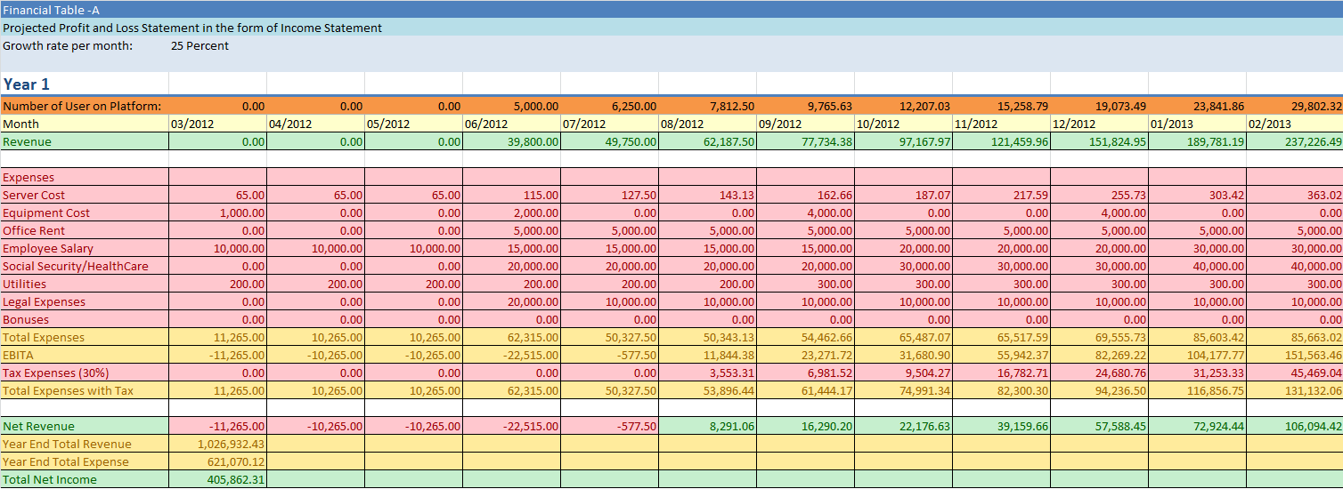

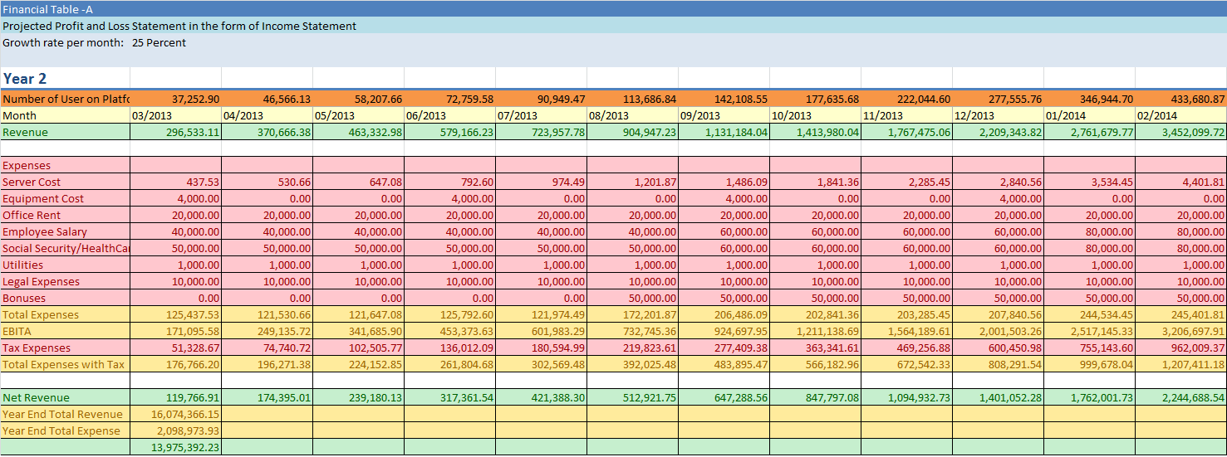

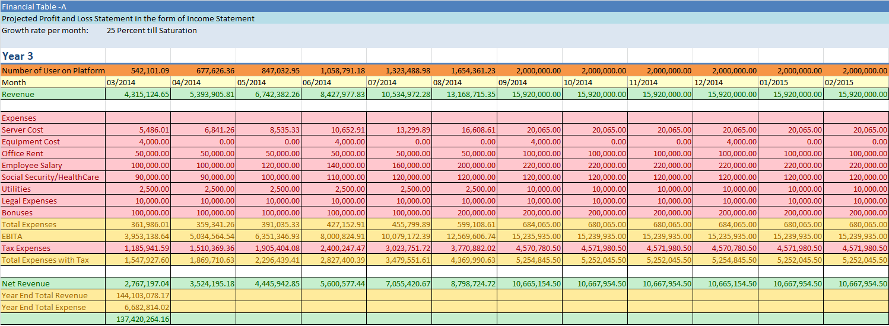

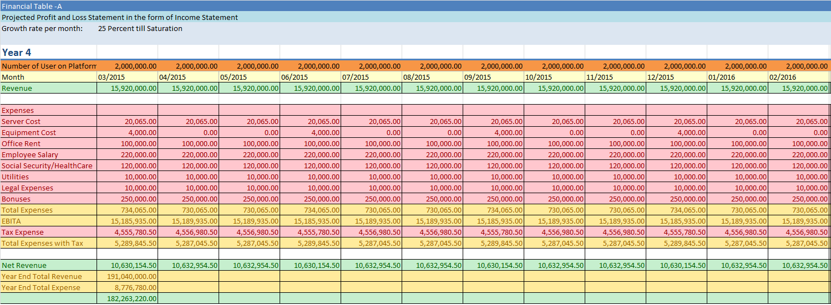

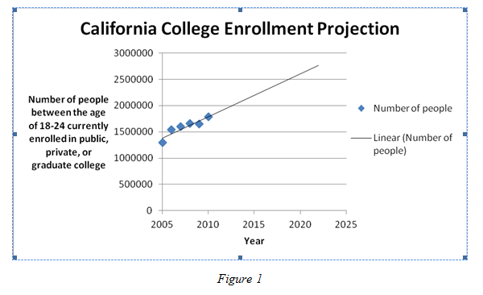

*Note the first point is at -60,000 Due to scaling, it is difficult to see the negative value.

- Bibliography

Byers, Thomas H., Richard C. Dorf, and Andrew J. Nelson. Technology Ventures, From Idea To Enterprise. 3rd ed. McGraw-Hill Science/Engineering/Math, 2011.

Dungeons and Dragons. Wizards of the Coast, 24 Feb, 2012. Web. 25 Feb, 2012
<http://www.wizards.com/DnD/Default.aspx>

Fantasy Ground, SmiteWorks, 2010. Web. 25 Feb, 2012 < http://www.fantasygrounds.com/>

Forrestor Reports. Forrester Research Inc. Web. 25 Feb, 2012< http://www.forrester.com/rb/research/>

U.S. Department of Commerce. United States Census Bureau. U.S. Department of Commerce. Web.
22 Feb, 2012. <http://www.census.gov/>

